15 mark

Program-level performance refers to the overall efficiency and effectiveness of a software program or application. It encompasses various aspects, including:

1. \*\*Speed\*\*: How quickly the program executes its tasks or processes. This is often measured in terms of response time or throughput.

2. \*\*Resource Usage\*\*: The program's consumption of system resources, such as CPU, memory, and disk space. Efficient resource utilization is crucial for optimal performance.

3. \*\*Scalability\*\*: The ability of the program to handle increased workloads or users without a significant decrease in performance. Scalable programs can adapt to changing demands.

4. \*\*Reliability\*\*: The program's ability to consistently perform its intended functions without errors or crashes. High reliability is essential for critical applications.

5. \*\*Robustness\*\*: How well the program handles unexpected or erroneous input, preventing crashes or security vulnerabilities.

6. \*\*User Experience\*\*: The overall satisfaction of users while interacting with the program. This includes factors like user interface design, responsiveness, and ease of use.

7. \*\*Energy Efficiency\*\*: For mobile or battery-powered devices, minimizing energy consumption is crucial to extend battery life.

8. \*\*Maintainability\*\*: The ease with which the program can be updated, modified, or debugged. Well-structured and documented code contributes to maintainability.

To improve program-level performance, developers often employ various techniques, such as code optimization, algorithm improvements, caching, load balancing, and profiling tools to identify bottlenecks. Performance testing and monitoring are also essential to assess and maintain a program's performance over time.

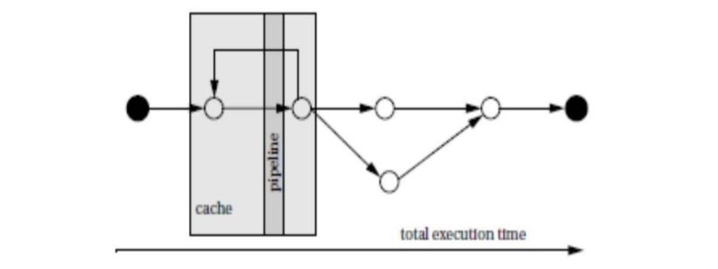

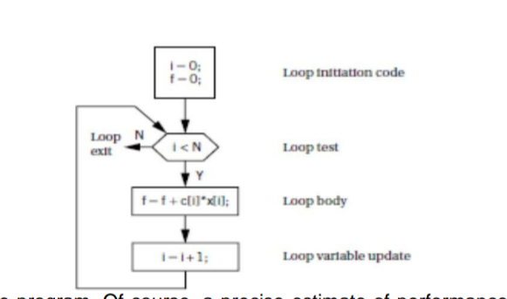

Resource utilization, response time, and throughput are all important factors in assessing program-level performance.

\*\*Resource utilization\*\* measures how efficiently a program is using its resources, such as CPU, memory, and disk space. A high resource utilization can indicate that a program is inefficient or that it is not using the available resources effectively. This can lead to performance problems, such as slow response times and high throughput.

\*\*Response time\*\* is the amount of time it takes for a program to respond to a request. A fast response time is important for programs that need to interact with users in real time, such as web servers and online games. Slow response times can frustrate users and lead to a loss of productivity.

\*\*Throughput\*\* is the number of requests that a program can process per unit time. A high throughput is important for programs that need to process a large number of requests, such as database servers and search engines. A low throughput can lead to bottlenecks and delays.

These three factors are interrelated and can have a significant impact on program-level performance. For example, a program that is inefficient and uses a lot of resources will likely have slow response times and low throughput. Conversely, a program that is efficient and uses resources wisely will likely have fast response times and high throughput.

Here is an example of how these three factors can contribute to the overall assessment of program-level performance:

A web server is a program that serves web pages to users. The response time of a web server is important because users expect web pages to load quickly. If a web server has a slow response time, users are more likely to abandon the website.

The throughput of a web server is also important because it determines how many users the web server can serve simultaneously. If a web server has a low throughput, it may not be able to handle a large number of users, which can lead to outages.

The resource utilization of a web server is also important. If a web server is using too many resources, it can lead to performance problems, such as slow response times and high throughput.

Therefore, the overall assessment of a web server's performance would take into account all three of these factors: response time, throughput, and resource utilization.

In general, a program with fast response times, high throughput, and low resource utilization is considered to have good performance.